## Install/Enable IIS on Windows Server

* 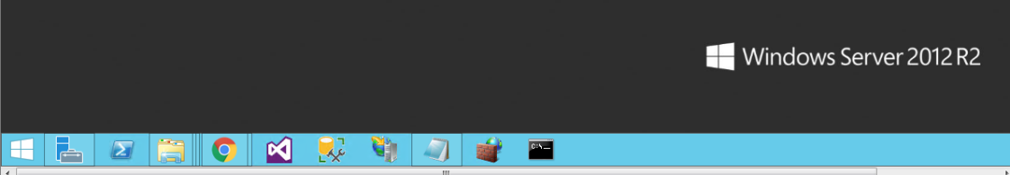Start **Server Manager**.
* 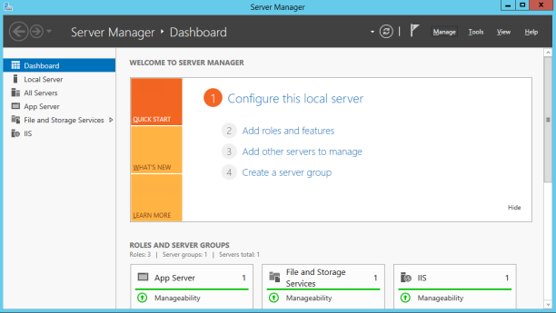On Server Manager, Select “**Add roles and features**” option.
* 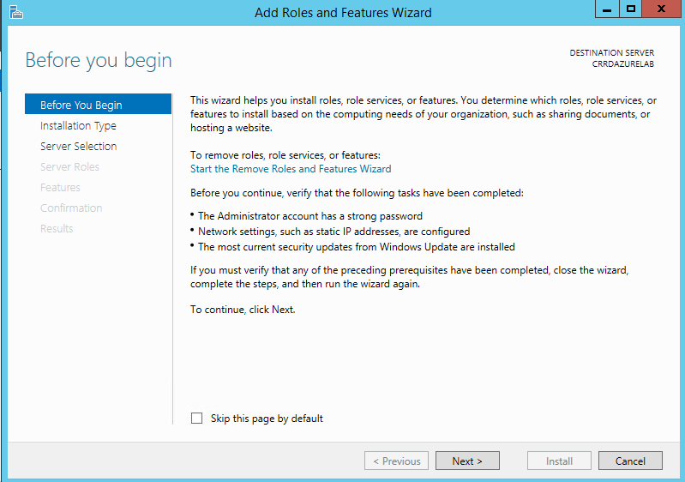Next, On the Add Roles and Feature Wizard panel will show. Click‘**Next**’.
* 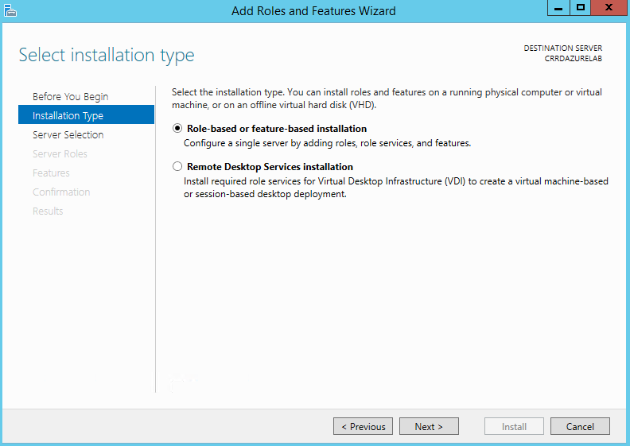On the Select Installation tab, choose first option “**Role-based or feature-based installation”.**

.

* 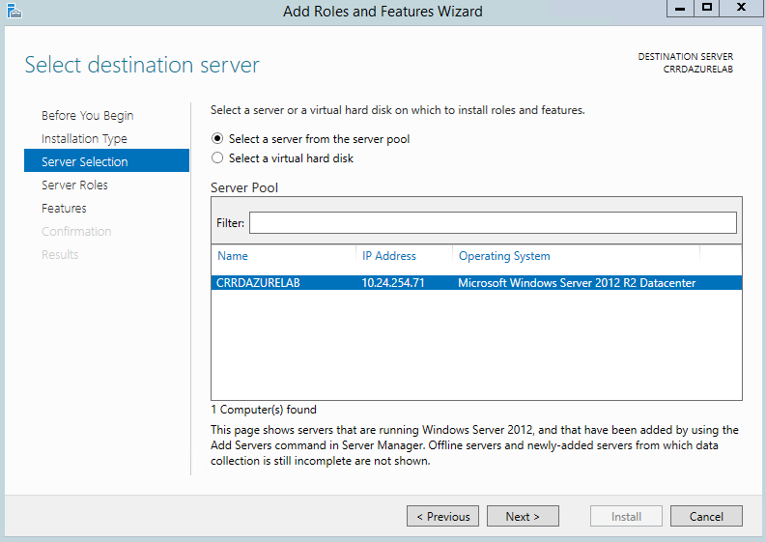On Server Selection, Leave default then click ‘**Next**’.
* 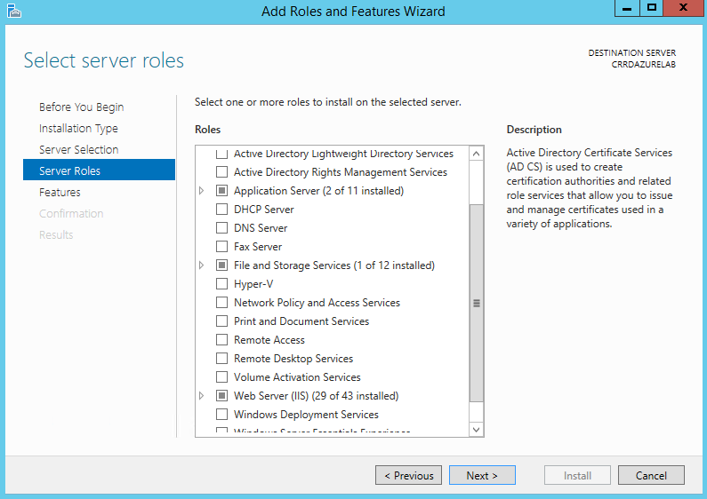In Server Roles add “**Application Server” & Web Server(IIS)**” , then click ‘**Next**’.
* 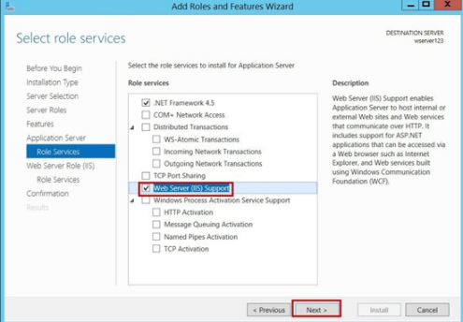On Role Services, check **Web Server (IIS) Support**, then click ‘**Next**’.
* Choose IIS 6, then click ‘**Next**’.

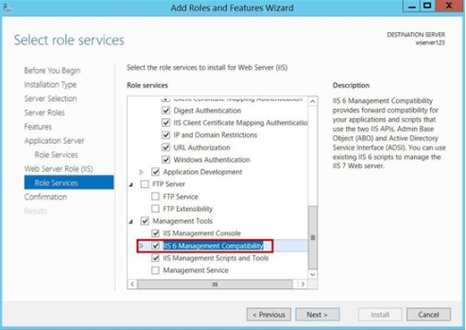

* Wait for the installation to finish. When the installation complete, then click close.

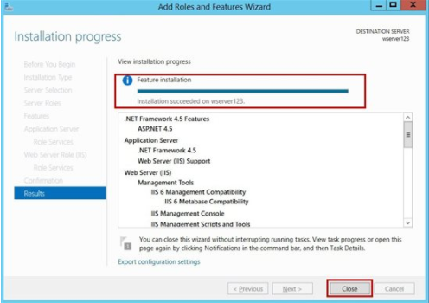

* To confirm that the installation succeeded, type the following URL into your browser**,**[**http://localhost**](http://localhost/). The page should look like the below image.

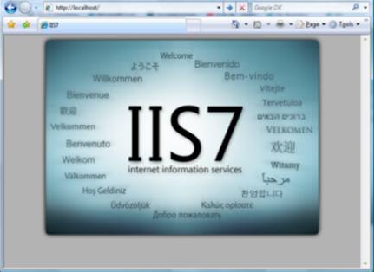

**Note:** The image on the page will depends on what IIS version installed.